**DISABLING POP-UP NOTIFICAITONS**

This app uses a new feature of Android Oreo called push-notifications. As a result of which the song control panel of the notification bar pops up when any changes are made to the song playback. For e.g. next song is played or the song is paused so that you can change the song, play/pause while working on other apps without the hassle of opening the Echo app again  
or pulling down the notification panel to do the same

However, some users might find it a bit irritating or a distraction. Hence, they can always change that behaviour by modifying the notification setting of the app by following the given steps:

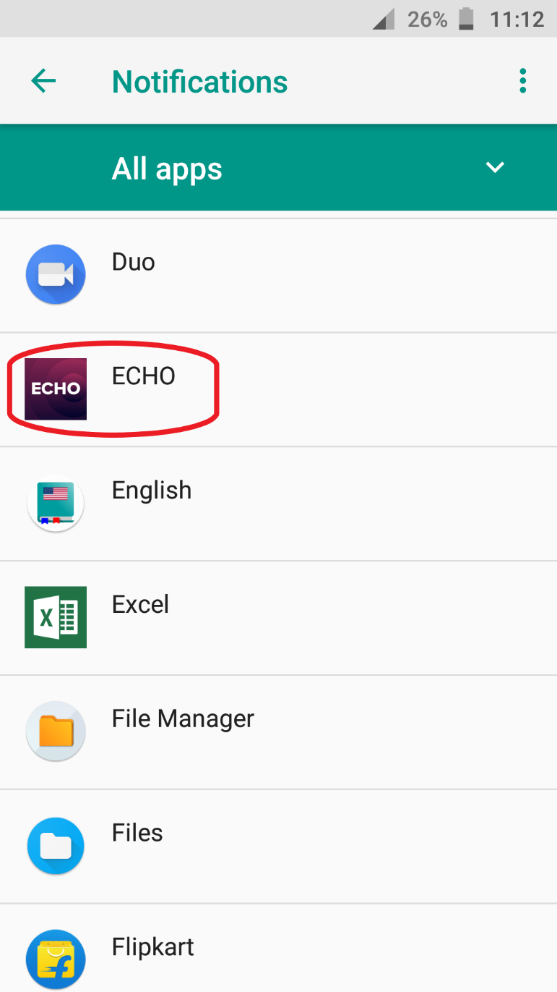

1)

Open the Settings app and go to Apps & Notifications (or equivalent settings if you are running a custom UI) and open Notifications.  
Click on Echo in the list

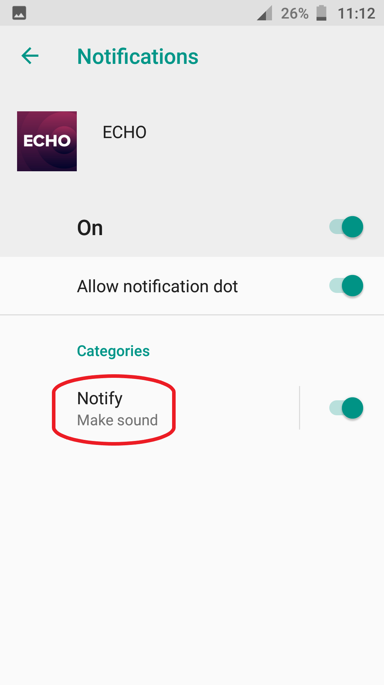

2)

Tap on notify under Categories

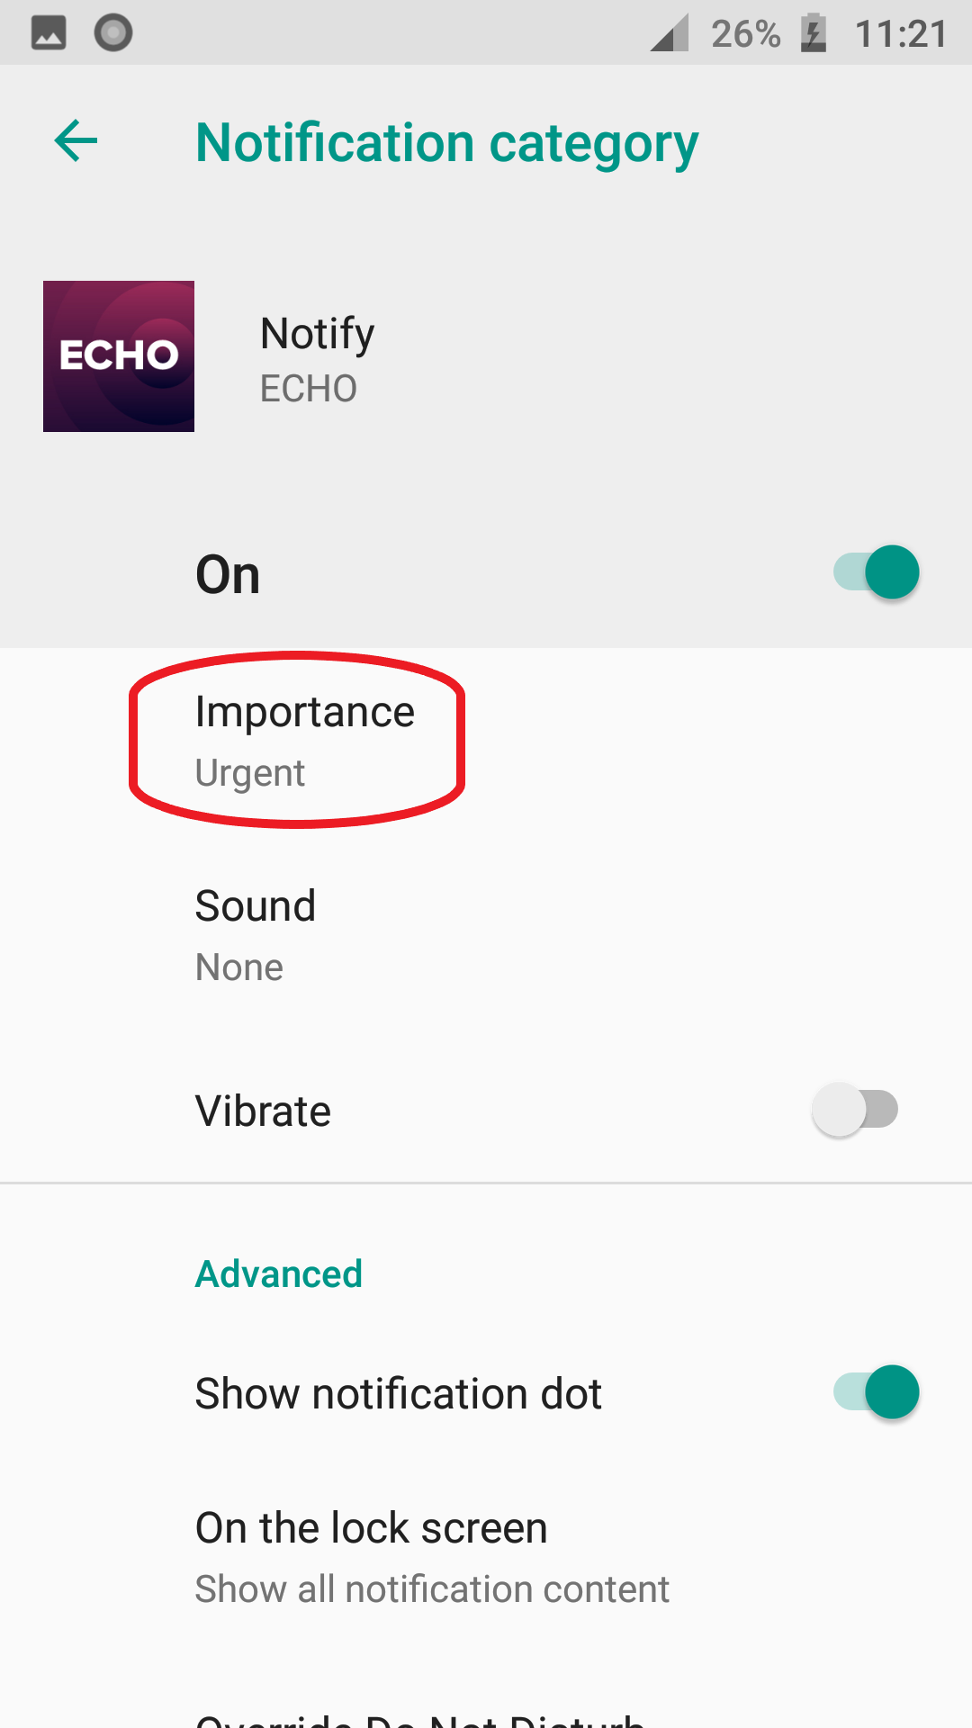

3)

Tap on Importance (which would be set to urgent by default)

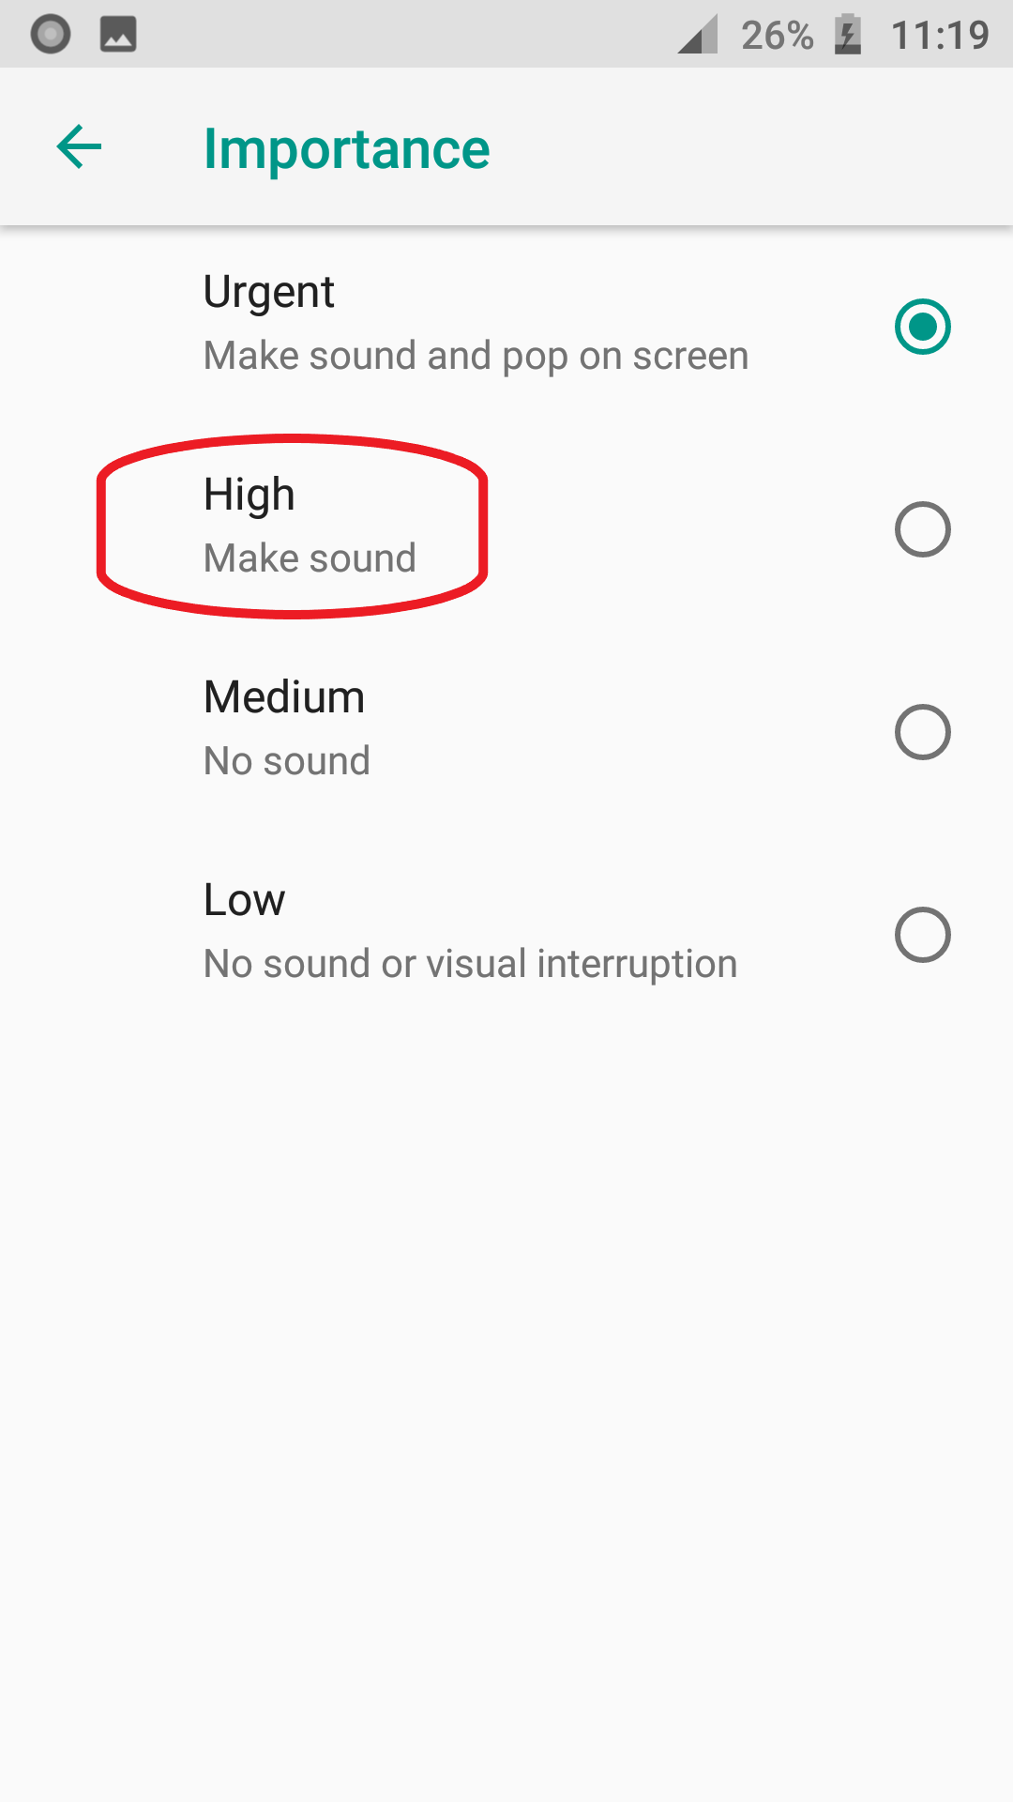

4)

Select High from the list

AND YOU ARE DONE!!!